Example of function with required parameters

def simple_interest(amt,t,rate):
si=(amt*t*rate)/100
print(f'Simple Interest is {si:.2f}')

#Main Program
simple_interest(5000,12,1.5)
simple_interest(5000,24,2.5) # Positional arguments
simple_interest(rate=1.6,amt=9000,t=24) #Keyword arguments

Output
Simple Interest is 900.00
Simple Interest is 3000.00
Simple Interest is 3456.00

Example:
users={'nit':'n123',
'naresh':'naresh1234',
'suresh':'suresh123@x'}

def login(u,p):
if u in users and users[u]==p:
print(f'{u},welcome')
else:
print("invalid username or password")

#Main
print("*********Login***********")
username=input("UserName :")
password=input("Password :")
login(username,password)

Output
UserName :naresh
Password :naresh123
invalid username or password

*********Login***********
UserName :naresh
Password :naresh1234
naresh,welcome

return keyword
A function return the value to the caller or calling function using “return” keyword.
“return” is branching statement which is used to control the execution of function.
“return” keyword/statement, after returning value, it terminates execution of function.

Syntax:
def function-name([parameters]):
statement-1
statement-2
return expression/value

whenever function returns value, it is assign to variable.

Example:
def fun1():
x=100
print(x)

def fun2():
x=100
return x

fun1()
a=fun2()
print(a)
b=max(10,20,30)
print(b)

Output
100
100
30

Example:
def maximum(a,b):
if a>b:
return a
else:
return b

#Main
num1=int(input("Enter First Number "))
num2=int(input("Enter Second Number "))
num3=maximum(num1,num2)
print(f'Max of {num1} and {num2} is {num3}')

Output
Enter First Number 10
Enter Second Number 20
Max of 10 and 20 is 20

Example:
def fun1():
return 10
print("Hello")

x=fun1()
print(x)

Output
10

Example:
def fun1():
return 10
return 20
return 30

x=fun1()
print(x)

Output
10

Example:
def fun1():
return 10,20,30

x=fun1()
print(x,type(x))

Output
(10, 20, 30) <class 'tuple'>

Python functions are generic functions because these functions receive values of any type. Python is dynamically typed programming language the type variable is dynamic (based on value).

def add(a,b):
c=a+b
return c

r1=add(10,20)
r2=add(1.5,2.5)
print(r1,r2)
r3=add(1+2j,1+3j)
r4=add("PYTHON","PROGRAMMING")
print(r3,r4)

Output
30 4.0
(2+5j) PYTHONPROGRAMMING

Example:
# Write a function add only integer values

def add_int(a,b):
if isinstance(a,int) and isinstance(b,int):
return a+b
else:
return "NOTINT"

res1=add_int(100,200)
print(res1)
res2=add_int(1.5,2.5)
print(res2)

Output
300
NOTINT

Pass by address or Pass by reference
In pass by reference objects address is passed to function.

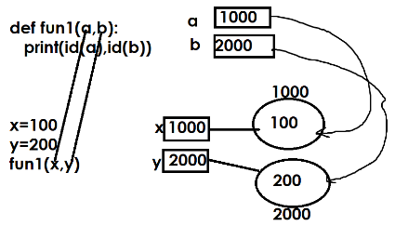
In pass by reference/address, if object is mutable the changes done within function is applied to original object

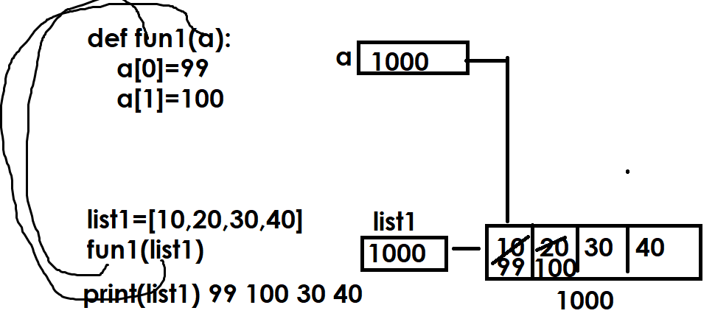

Example:
def sort_data(a):
for i in range(len(a)):
for j in range(len(a)-1):
if a[j]>a[j+1]:
a[j],a[j+1]=a[j+1],a[j]

list1=[5,2,4,1,3]
print(f'Before Sorting {list1}')
sort_data(list1)
print(f'After Sorting {list1}')

Output
Before Sorting [5, 2, 4, 1, 3]
After Sorting [1, 2, 3, 4, 5]

Function with required positional only parameters

Syntax:
def function-name(req-param1,req-param2,…,/):
statement-1
statement-2

the parameters followed by / are called required positional only parameters.
These parameters receives values using their positions but not using names.

Example:
def minimum(a,b,/):
if a<b:
return a
else:
return b

def min2(a,b):
if a<b:
return a
else:
return b

#Main Program
res1=minimum(10,20)
print(res1)
#res2=minimum(a=100,b=200)
res2=min2(100,200)
res3=min2(a=1,b=2)
print(res2)
print(res3)

Output
10
100
1

Function with required keyword only arguments

Syntax:
def function-name(*,param,param,param…):
statement-1
statement-2

*followed by any parameter is called keyword only parameter
These parameters receive values using name

Example:
def fun1(a,b,/):
print(a,b)

def fun2(*,a,b):
print(a,b)

def fun3(a,b):
print(a,b)

def fun4(a,b,/,*,c,d):
print(a,b,c,d)

#def fun5(*,a,b,c,d,/):
# print(a,b,c,d)

fun1(100,200)
fun2(b=1000,a=2000)
fun3(1,2)
fun3(a=1,b=2)
fun2(a=50,b=60)
fun4(10,20,d=30,c=40)

Output
100 200
2000 1000
1 2
1 2
50 60
10 20 40 30

Example:
def str_upper(s):
s1=""
for ch in s:
if ch>='a' and ch<='z':
s1=s1+chr(ord(ch)-32)
else:
s1=s1+ch
return s1

str1=str_upper("python")
print(str1)

Output
PYTHON

Example:
def is_prime(num):
c=0
for i in range(1,num+1):
if num%i==0:
c=c+1
return c==2

#Main
number=int(input("Enter any number "))
if is_prime(number):
print("prime")
else:
print("not prime")
Output
Enter any number 5
prime

Enter any number 4
not prime

Function with default parameters or optional parameters

